3D PRINTED WOODWORKING AIDS
Don Snyder Sept. 2020

Below is a drawing of a woodworking aid I designed in August for 3D printing. With a dial indicator mounted on it, the aid is used to set saw blades accurately and repeatably to 90° from the saw’s surface [1]. The aid can also be used to set fences on table saws and jointers to 90°. Setting 45° and other angles is also possible.

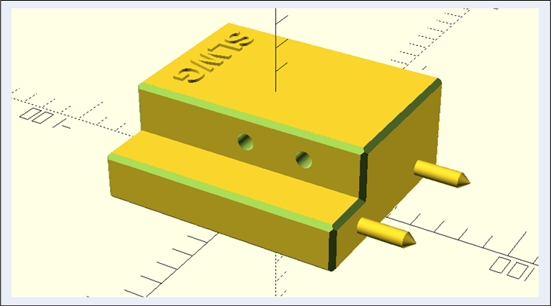

The picture below is of the 3D printed aid without and with a dial indicator mounted on it.

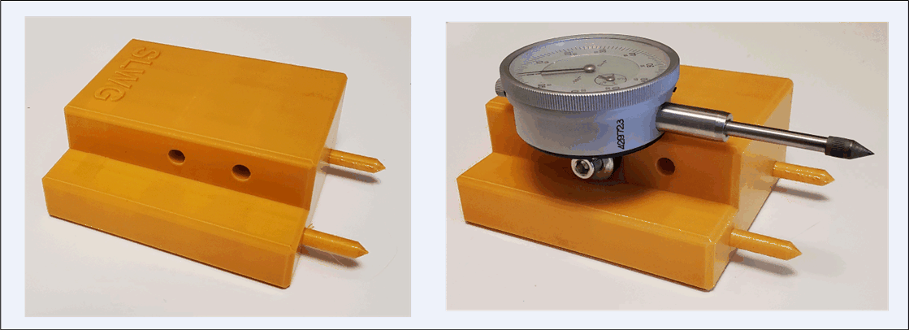

I designed this aid using OpenScad, which is readily available, free software for doing 3D designs and producing STL files used by 3D printers [2]. Minimal coding skills are needed to use OpenScad, but it helps to remember a little about the order of doing operations with vectors and matrices. Using this guide to set the angle of a saw blade or fence requires presetting the dial indicator to zero at the desired angle. 3D printed angle guides can be used for this calibration. Shown below are three guides I designed for 45°, 22.5° (from vertical) and 90° angles using OpenScad and then 3D printed. Guides for other angles can be made without requiring any additional OpenScad coding; all that is needed is to set the angle parameter in the existing code. This kind of parameterization is one of the attractive features of OpenScad.

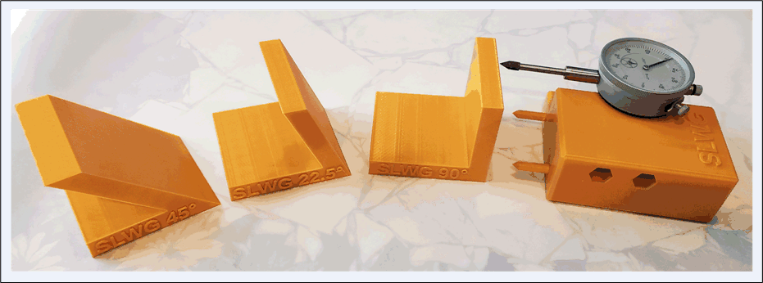

Two other woodworking aids I designed using OpenScad and then 3D printed are shown below. One is made to hold the KM-1 Kerfmaker device of Bridge City Tools, which is used for making accurate kerfs, grooves, dados and cross-lap joints [3, 4]. Shown below is an OpenScad drawing of the Kerfmaker holder and a printed holder with the KM-1 Kerfmaker and a magnetic switch in the holder; the magnetic switch permits the holder to be placed in position on a saw’s surface and then firmly keeps it in place while using the Kerfmaker to cut accurate kerfs.

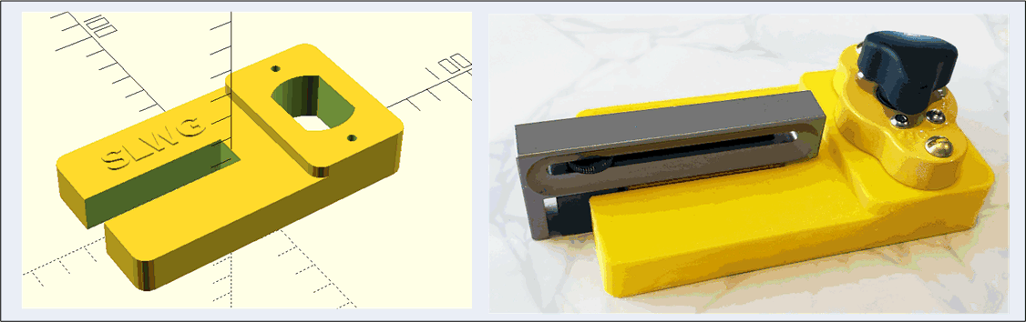

The other aid is used to simplify sharpening rectangular and curved scrapers using Peter Galbert’s method [5].

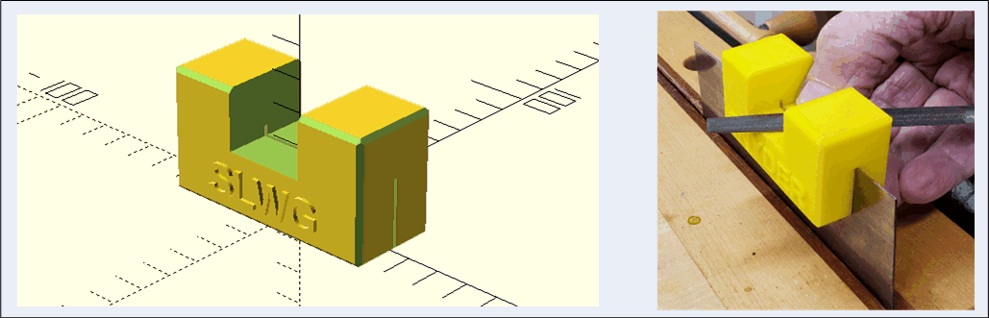
3D printers can be used to make aids for woodworking, and OpenScad is a free software program that can be useful for accomplishing the design of the aids.

- https://www.bing.com/videos/search?q=dial+indicator+sawblade+angle&docid=607998065924834424&mid=7B0D688152BEE2E766827B0D688152BEE2E76682&view=detail&FORM=VIRE
- http://www.openscad.org/
- https://bridgecitytools.com/products/km-2v2-kerfmaker-pro
- https://www.rockler.com/bridge-city-tools-km-1-kerfmaker
- Peter Galbert, “Sharpen and use a curved card scraper,” Fine Woodworking, pp. 20-25, Nov/Dec 2018.

