IMAGINE GROVE
Scott Grove
scott@scottgrove.com
585-738-2288

Instructions for connecting to a group meeting with Zoom
First, you need to download the software. You do not need to sign up for an account with Zoom, nor do you need to enter a "free trial" of a paid account. It is FREE to join my meeting through Zoom.
Click this link: https://us04web.zoom.us/j/5618273636 or copy it into your browser. A browser window will open, and Zoom will initiate a download of the software that you need. Follow the prompts to install the software. This is done only the first time you join a Zoom meeting on a computer or device.
Note: You will be given a unique ID and link for your meeting. The link above will not be used on meeting day.
You can click on “Open Zoom” or “download & run Zoom.” If you click on “click here” you will be prompted to “Open Zoom.” If you can’t download the software, click on “join from your browser.”
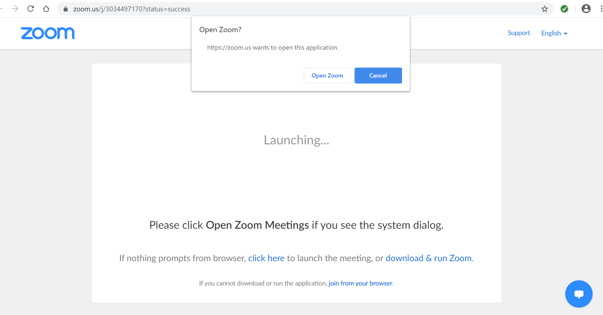
You will then be prompted to enter a meeting password. You will receive this password from me or your group’s organizer.
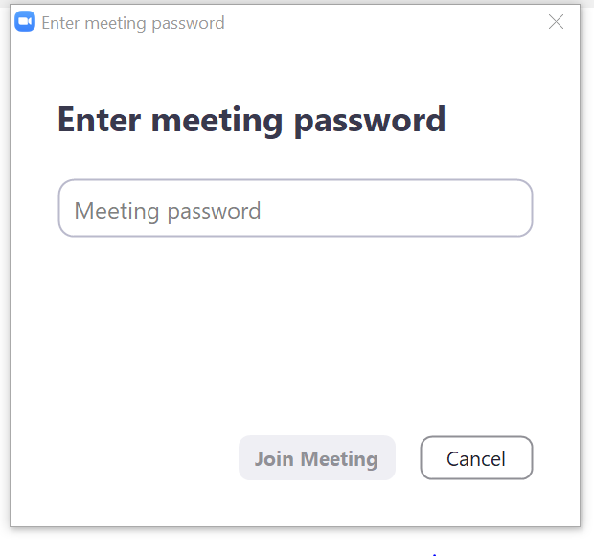
Zoom offers a video tutorial here: https://support.zoom.us/hc/en-us/articles/201362193-How-Do-I-Join-A-Meeting-Setting
Once you are on Zoom, I’ll send you an invitation to join the meeting, and we’ll be connected by video.
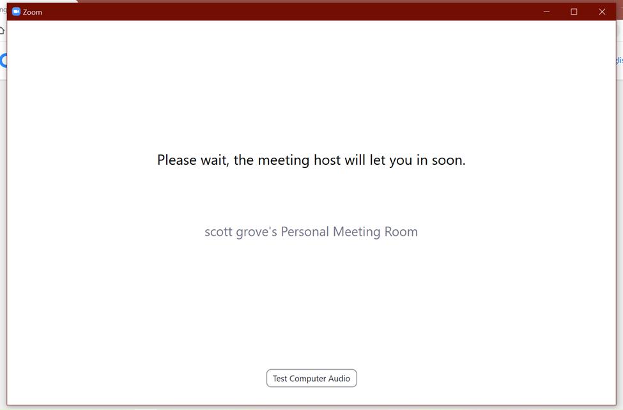
Setting yourself up in the meeting:
You can connect with video and audio so that you can hear the demo, and others can see and hear you. Fill in your first and last name. If you want to join with video (facing yourself), click on the “Join with Video” button.
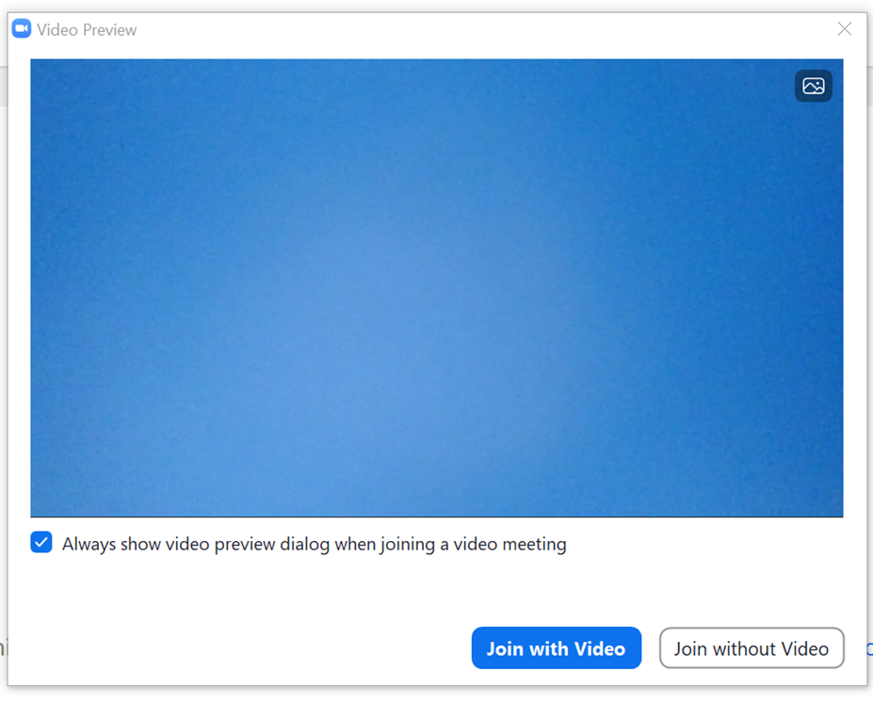

Note: You do not need a camera or microphone to join the meeting and see what’s on the camera, but you need speakers on your computer or a headset to hear it. If you chose the “Join without Video” option, the others will not be able to see or hear you.
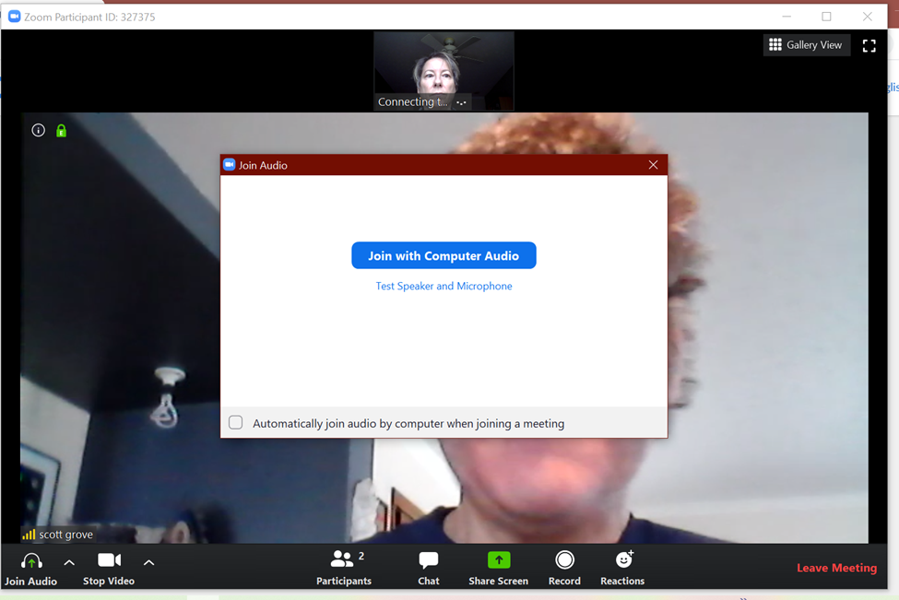
If your computer (or headset attached to your computer) has a microphone, you will have better audio. Click the “join with computer audio” button. If your device does not have a microphone and speaker, you can use your phone as a microphone and speaker.
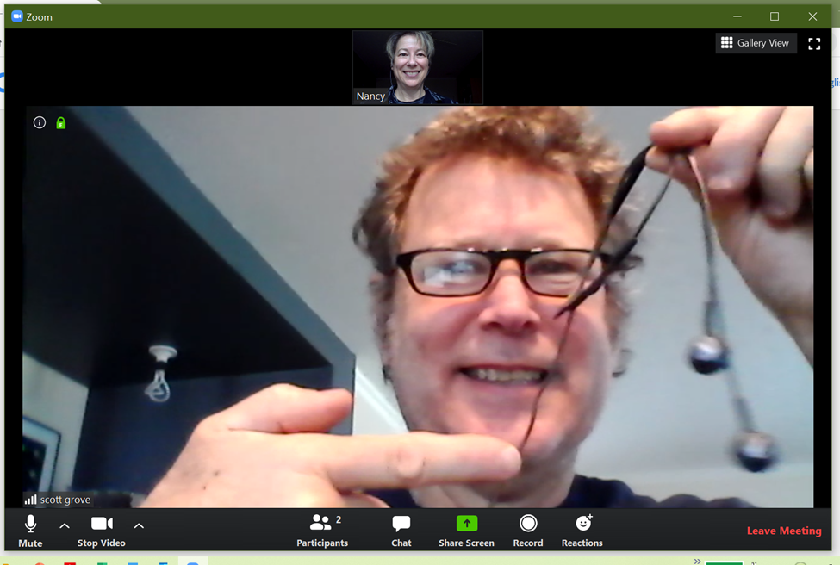
Go to the bottom row of the Zoom window, and you will see a row of icons. The far left is a microphone icon. This is where you mute or un-mute your own microphone. The icon to the right of that is a video camera icon. This enables meeting attendees to see a thumbnail of you on live video. Click these icons to turn on or off your audio or video. It’s best to mute your audio unless you have a question, otherwise everyone will hear what goes on in your background (dog barking, kids playing, etc.).
Note: The row of icons at the bottom of the screen is hidden if there is no mouse activity. Move your mouse to get the icons back when you want them.
If your video and audio don't connect automatically (or don’t work), click on the triangle to the right of the microphone icon, open the drop down menu, and choose "Audio Settings". Here you can choose which speaker and microphone you are using, and can check them to see if they are working. If you are on a Mac, you might have to go to System Preferences and select which speaker and microphone you want the computer to use.
On the left side of the settings window is a sidebar. Choose "Video" to select which camera your computer will use to connect to the meeting. You can also get to Video Settings by clicking the up arrow to the right of the video camera icon and choosing “Video Settings”.
Using the Chat feature:
There is an icon labeled Chat at the bottom of the Zoom window. When you click on it, a sidebar opens on the right with a Chat Window. If you are in full screen mode, Chat opens in a separate window. In the “To:” field at the bottom, you can choose who you want to message - either everyone or to Scott privately. Type your message where it says “Type message here”, and press Enter to send it.
Message Everyone:
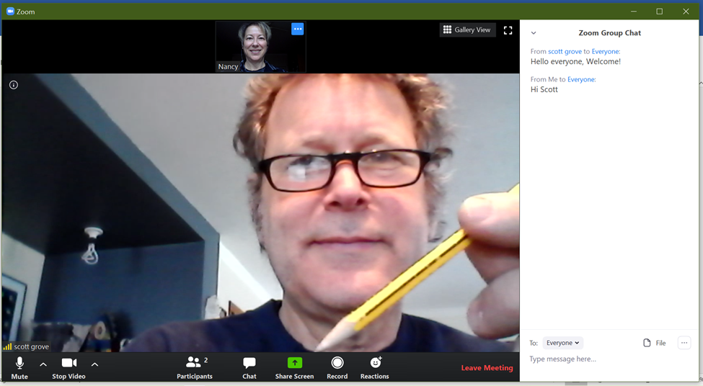
Message Scott Privately:
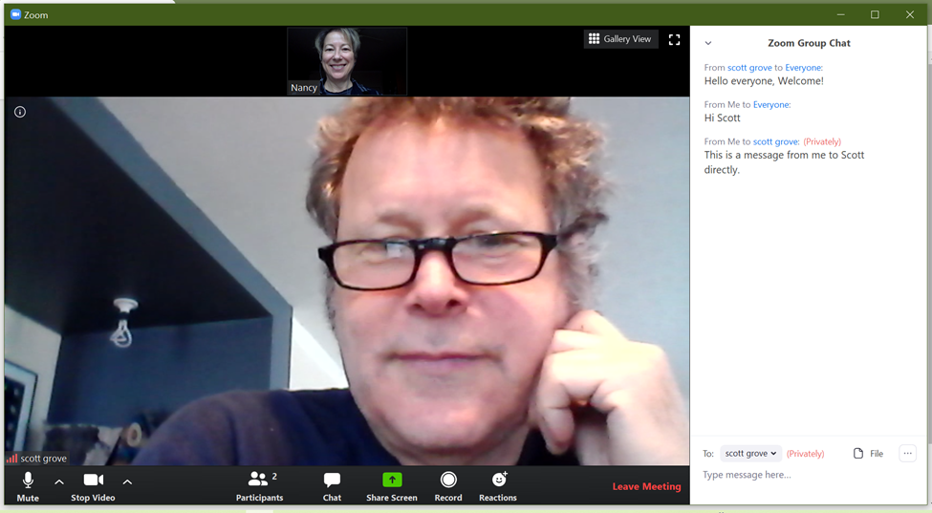

Asking questions during the meeting:

You can ask questions during the demo or wait until the end. To ask a question, un-mute your microphone and speak. If you don't get my attention that way, use the Chat feature to get the Moderator's attention, and he/she will let me know.

Leaving the meeting:

You can leave any time, and you can come back by clicking the link again and joining the meeting. To leave the meeting, click "Leave Meeting" at the lower right of the Zoom window.

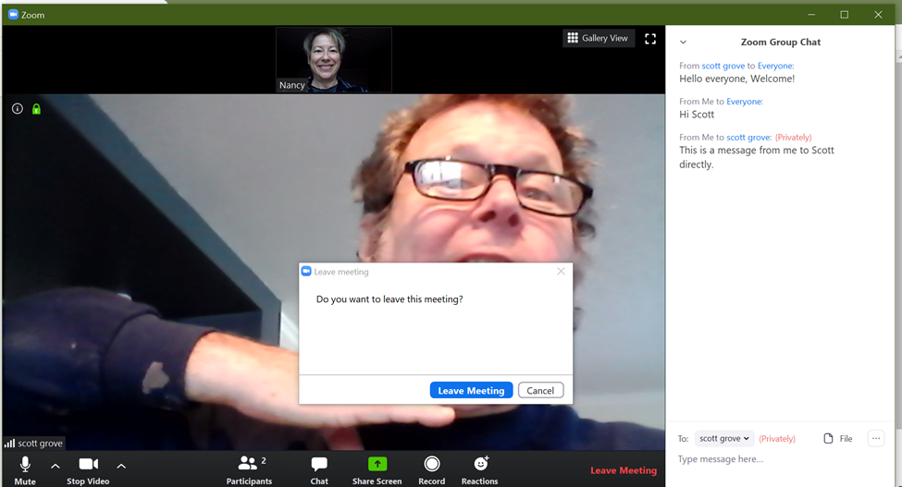

Additional controls:

You can change your name later if you didn’t do it when you first joined. Right click on the “…” icon on your thumbnail video, or click “More” in the Participant window, and select Rename.

Click the Participants icon at the bottom of the screen to see who has joined the meeting.

You can connect to the meeting with your laptop or phone, and connect it to your TV with an HDMI cable (your phone needs an adapter).

Viewing the meeting in Full Screen:
You can make the Zoom window take up the full computer or TV screen by double clicking on the large video in Speaker View. Double click again to exit Full Screen Mode. There is also an icon for full screen in the top right corner of the window. In Full Screen, the film strip becomes a separate window. You can minimize the film strip by clicking the flat line icon at the top left of that window. You can also click and drag the film strip (minimized or not) anywhere you want.
Speaker view, Gallery view:

When you join the meeting, it opens in Speaker View, and you see a large video and a film strip of thumbnails (the other participants’ videos). Before the meeting starts, the person who is speaking is shown in the large video. Once the meeting starts, the host or co-host will spotlight the demonstrator’s video so that is what everyone sees no matter who is talking. In Speaker View, the words “Gallery View” (or a grid icon) are in the upper right corner of the Zoom window. Click this for Gallery View.

In Gallery View, you see a grid of small videos of the participants. The person who is speaking has a yellow border. Click the words “Speaker View” in the upper right corner of the window to return to Speaker View. Gallery View can be nice for socializing before the meeting.

Tablet/Phone support:

If you are using a tablet or phone, you need to go to the App Store or Google Play to download the Zoom App.

Start the App, and type in (or choose) the meeting ID.

The Zoom session should start as described above. You have all of the above functionality, but the buttons may be in different places. Tap the screen to display the buttons.

On an iPad, the Chat feature is under the “…” button in the top right corner.

Keep in mind that the meeting streams in HD, so you may use a lot of data.

