

**Introduction to Veneer**

Scott Grove, internationally-renowned master craftsman, introduces you to the wonderful world of veneer. He covers veneering fundamentals that includes buying, inspecting, matching, cutting, seaming, and pressing. Scott shares lots of tips, tricks, and techniques that will leave you inspired and ready to start your first veneering project. During the live, interactive demonstration, his wife and co-host, Nancy, helps organize Q&A and provides tools and supplier resource links in real time, too.

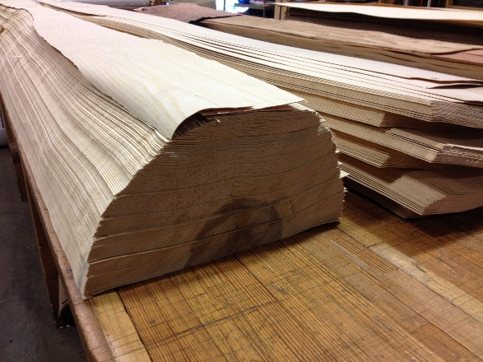 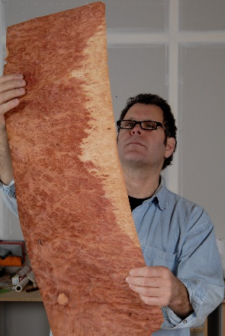 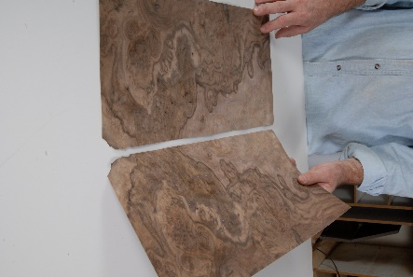

You can see Scott in action on his educational site [ImagineGrove.com](https://imaginegrove.com): review his personal work at [ScottGrove.com](http://www.scottgrove.com): and buy his books and other products from [ImagineWoodworking.com](https://www.imaginewoodworking.com). Follow him on social media [here](https://linktr.ee/scottgrove).

